Temperature and Humitidy sensor

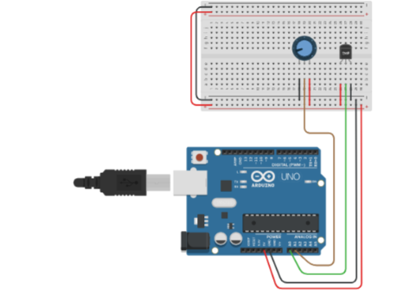

Code:

#include <dht.h>

#define dht_apin A0 // Analog Pin sensor is connected to

dht DHT;

void setup(){

Serial.begin(9600);

delay(500);//Delay to let system boot

Serial.println("DHT11 Humidity & temperature Sensor\n\n");

delay(1000);//Wait before accessing Sensor

}//end "setup()"

void loop(){

//Start of Program

DHT.read11(dht_apin);

Serial.print("Current humidity = ");

Serial.print(DHT.humidity);

Serial.print("% ");

Serial.print("temperature = ");

Serial.print(DHT.temperature);

Serial.println("C ");

delay(5000);//Wait 5 seconds before accessing sensor again.

//Fastest should be once every two seconds.

}// end loop(